Business, Society and Technology
IFE, 3rd semester

LAB REPORT
MANUFACTURING
Lab no. 16
Title: The manufacturing of polymer products with use the screw injection moulding machine

Date of lab: 30/10/2025
No. | SURNAME Name | Album No. | Lab group
1. | OGŁUSZKA Michał | 257104 | BST_en_1
2. | KOTOWICZ Stanisław | 257100 | BST_en_1
3. | GARA Maciej | 257093 | BST_en_1

- INTRODUCTION (Task 1)
This laboratory session covered production of polymer parts using a screw injection-moulding machine. Injection moulding is a high-volume manufacturing technology in which molten polymer is forced into a shaped cavity (the mould) and allowed to solidify to form the final part. In the lab we worked with a bench-scale screw injection machine and examined the whole process chain: raw-material handling, plasticising in the screw, injection and packing and ejection of the part as well.

  - Types of materials
- Thermoplastics: PVC (window profiles, containers, cases), filament materials such as PLA or PETG or ABS plastics. Thermoplastics can be heated, reshaped and, most importantly, remelted and reused. This is an important difference from thermoset polymers, which cure irreversibly and cannot be remelted.

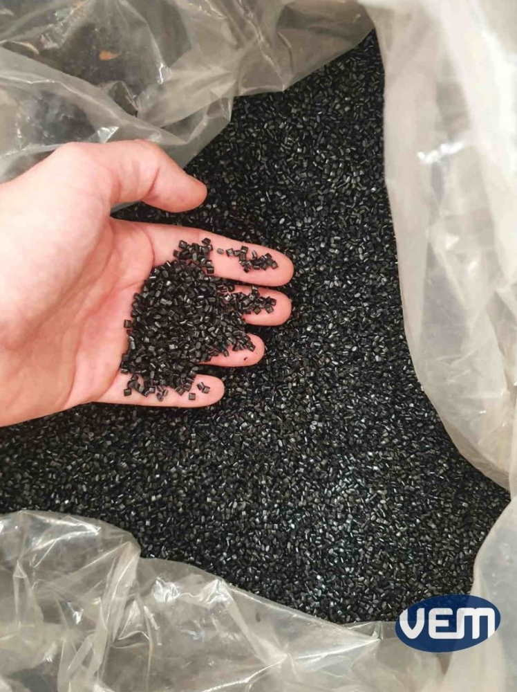
Fig.1 ABS plastic grains

- Thermosets: epoxy, phenolic resins. Thermosetting polymers cure through an irreversible chemical reaction. Once cured, they cannot be remelted or reshaped. They offer high thermal stability, chemical resistance and stiffness, but cannot be recycled by melting.
  - Stages of production proces
The injection-moulding cycle observed in the lab can be described step-by-step:
- Screw load: the polymer pellets are fed from the hopper into the barrel where the rotating screw conveys, compresses and shears them. Heaters on the barrel melt and homogenize the material.

- Injection: the screw moves forward and forces the molten polymer through the nozzle into the mould cavity. Injection time in small parts is typically a few seconds.

- Packing: after the cavity fills, additional pressure is applied to compensate for shrinkage and avoid deformation. This extra push is critical to attain dimensional accuracy. In the lab machine we select the packing pressure; the mould must resist this pressure — in our laboratory’s session the machine’s maximum closing force noted was 550 kN.

- Cooling / Solidification: the melt cools in the mould and solidifies to take the part shape. Cooling time is a major part of the cycle. The bench mould used in the lab did not have cooling systems (for lab purposes). Cooling was done naturally by just simply resting. In industry, moulds have controlled cooling systems and heat must be carefully controlled.

- Ejection: once sufficiently cooled, the mould opens and an ejection system pushes the sample out. Every mould contains an ejection system (pins, plates) to remove parts. When a multi-cavity mould is used several elements can be produced per shot — visible stamps (parting lines) may be visible as a result of this.

- Inspection: removing flashes and checking surface quality and dimensions.

- EXPERIMENTAL

Description of the experiment
During the laboratory, several plastic samples have been made using a screw injection molding machine. The experiment focused on investigating the effect of key technological parameters—specifically, injection pressure and injection time—on the molded parts.

Technological parameters of moulding
The key technological parameters of injection moulding include melt temperature, mold temperature, time of injection, injection pressure and holding pressure. During laboratory we focused on 2 parameters which are most crucial: time of injection and pressure.

Number of sample: | Pressure: | Time of injection:
1. | 1000 bar | 0.8 s
2. | 800 bar | 0.8 s
3. | 400 bar | 0.3 s
4. | 400 bar | 0.5 s
5. | 400 bar | 0.8 s

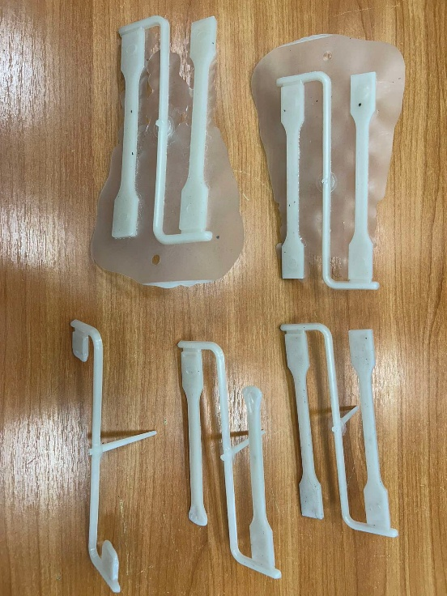

Assesment of Injection Molded Sample Quality
The experimental samples, produced using a screw injection molding machine, exhibit quality issues directly tied to the varied settings of injection pressure and time. The samples from the high-pressure runs (1000 bar and 800 bar at $0.8$ s), visible in the top row, demonstrate a severe problem with flash, where the excessive force overcame the mold's clamping capability, squeezing molten plastic into the parting line and resulting in specimens surrounded by an uneven layer of unwanted material. Conversely, the samples from the low-pressure runs (all at 400 bar), visible in the bottom row as separated parts, successfully prevented flash, resulting in cleaner parting lines; however, this reduced pressure introduced the potential for short shots (especially at the lowest time of 0.3 s, where the material may not fully fill the mold cavity) and the risk of sink marks due to inadequate holding time and pressure necessary to compensate for material shrinkage. The overall quality assessment highlights the fundamental trade-off: high pressure causes visible flash, while low pressure avoids flash but risks incomplete parts or internal defects like poor consolidation, with the optimal setting lying at the minimum pressure but longer injection time of 0.8s which successfully eliminated flash and achieved a perfect part, confirming that 400 bar is the maximum pressure that avoids flash.

- CONCLUSIONS

The laboratory experiment utilizing the screw injection moulding machine successfully demonstrated the critical impact of technological parameters on the quality of polymer products. The results established a direct correlation between the injection pressure, time settings, and the occurrence of common defects. We observed that setting the injection pressure too high, specifically at 1000 bar and 800 bar, caused severe flash defects because the internal pressure overcame the mould's clamping force¹. Conversely, reducing the pressure to 400 bar effectively eliminated the flash and resulted in cleaner parting lines². However, the experiment also revealed that low pressure must be balanced with sufficient time; the shortest injection time of 0.3 seconds resulted in short shots where the material failed to fully fill the cavity³. Ultimately, the study identified that the optimal quality was achieved at a pressure of 400 bar combined with a longer injection time of 0.8 seconds, which ensured a complete fill without causing material overflow⁴. This confirms that successful manufacturing requires a precise balance of parameters to avoid both incomplete parts and excessive material leakage.

